1 | What are the three major variations of Decrease and Conquer design strategy?  Answer:  There are three major variations of decrease-and-conquer:  decrease by a constant  decrease by a constant factor  variable size decrease  In the decrease-by-a-constant variation, the size of an instance is reduced  by the same constant on each iteration of the algorithm. Typically, this constant is equal to one  The decrease-by-a-constant-factor technique suggests reducing a problem  instance by the same constant factor on each iteration of the algorithm. In most  applications, this constant factor is equal to two.  Finally, in the variable-size-decrease variety of decrease-and-conquer, the  size-reduction pattern varies from one iteration of an algorithm to another
2 | Write the algorithm for Insertion Sort and derive its best and worst case time complexities. Explain Insertion Sort Algorithm with the following data  12, 6, 2, 5, 11, 4, 8, 1  12, 6, 2, 5, 11, 4, 8, 1  6, 12 ,2 ,5, 11, 4, 8, 1  2, 6, 12, 5, 11, 4, 8, 1  2, 5, 6, 12, 11, 4, 8, 1  2, 5, 6, 11, 12, 4, 8, 1  2, 4, 5, 6, 11, 12, 8, 1  2, 4, 5, 6, 8, 11, 12, 1  1, 2, 4, 5, 6, 8, 11, 12
3 | Give the worst case complexity of Insertion Sort
10 | Give an algorithm for Topological Sort using DFS  - Step 1: Create a temporary stack.  - Step 2: Recursively call topological sorting for all its adjacent vertices, then push it to the stack (when all adjacent vertices are on stack). Note this step is same as Depth First Search in a recursive way.  - Step 3: Atlast, print contents of stack.
11 | 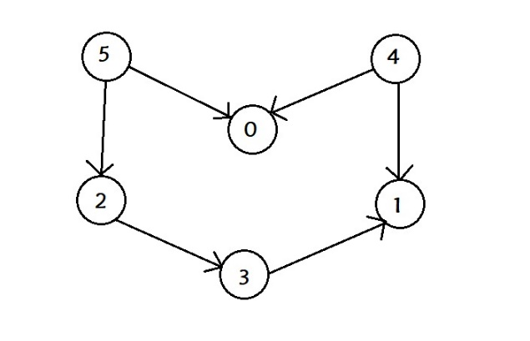  Apply Topological Sort to above graph  Ans:  